*Le Anh Duc (G0.HN)*

*International School | Vietnam National University*

*report*

Investigation of some Machine Learning methods for Type II Diabetes Mellitus screening using Raman Spectroscopy

Table of Contents

Introduction 2

Recent study 2

Use of Raman Spectroscopy 2

Machine Learning as a tool for non-invasive diabetes screening 2

Dataset 2

Data Preprocessing 5

Dimensionality Reduction 14

Support Vector Machine 15

# Introduction

Type 2 diabetes makes up about 90% of cases of diabetes, with the other 10% due primarily to type 1 diabetes and gestational diabetes.[[1]](https://en.wikipedia.org/wiki/Type_2_diabetes#cite_note-WHO2015-1) In type 1 diabetes there is a lower total level of insulin to control blood glucose, due to an autoimmune induced loss of insulin-producing beta cells in the pancreas.[[12]](https://en.wikipedia.org/wiki/Type_2_diabetes#cite_note-12)[[13]](https://en.wikipedia.org/wiki/Type_2_diabetes#cite_note-Green2011-13) Diagnosis of diabetes is by blood tests such as fasting plasma glucose, oral glucose tolerance test, or glycated hemoglobin (A1C).[[3]](https://en.wikipedia.org/wiki/Type_2_diabetes#cite_note-NIH2014Diag-3)

# Recent study

## Use of Raman Spectroscopy

There are numerous study about the use of Raman spectroscopy in various area such as plastic classification, fruit classification, wine classification, etc.

## Machine Learning as a tool for non-invasive diabetes screening

# Dataset

The data set is given on Kaggle by the author Edgar Guevana, for the pupose of improving their former result. There are total of 20 subjects corresponding to 20 observation of Raman at range 0 to 3159 cm-1. Each subject consists of 4 distinct measurement at their ear lobe, inner arm, thumbnail and cubital vein.

Below is the given dataset in spreadsheet form:

1. Ear lobe:

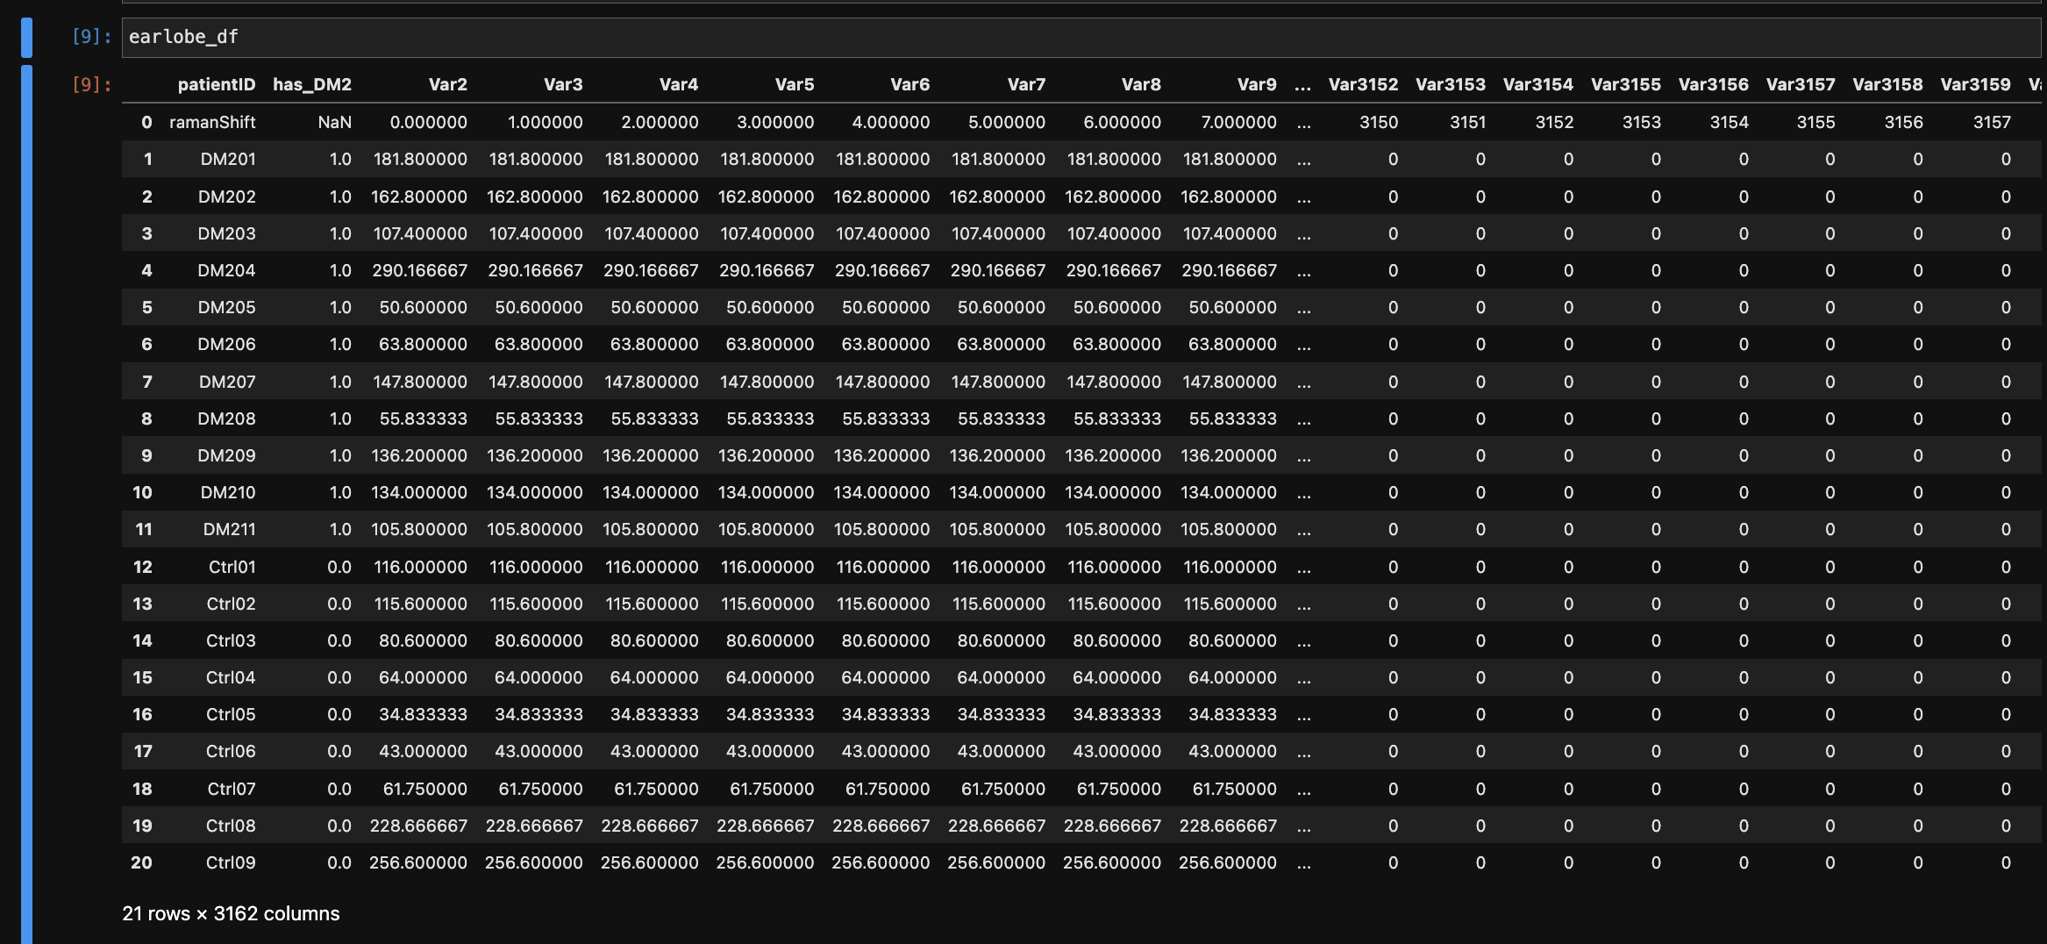

1. Inner Arm:

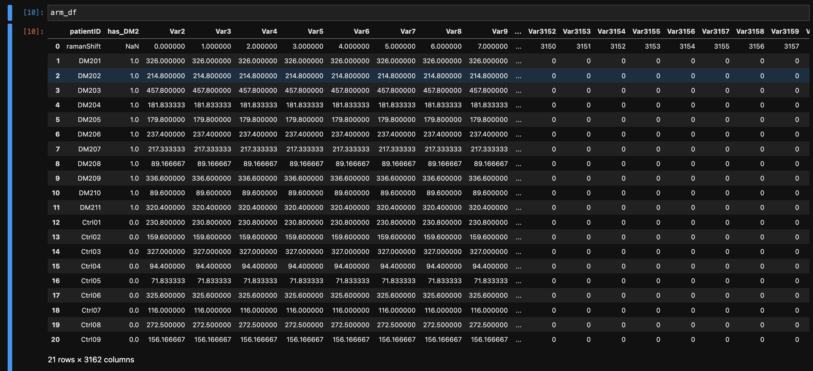

1. Thumb Nail:

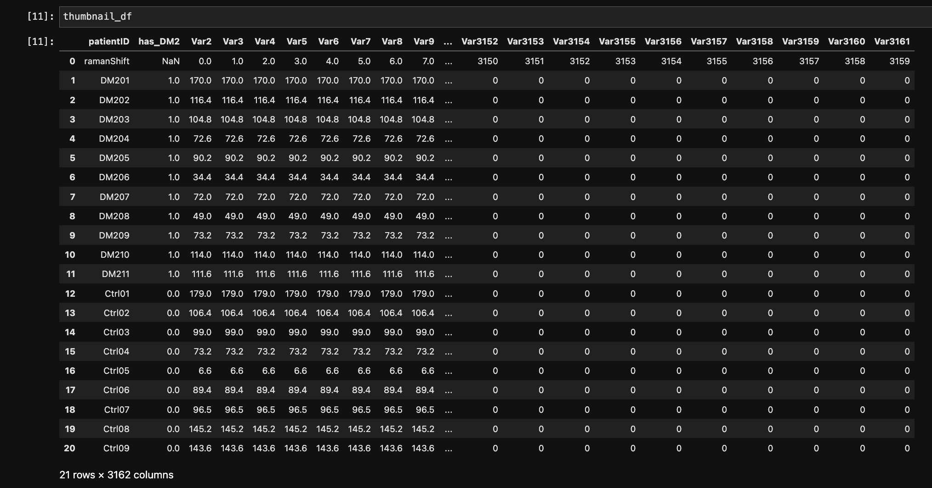

1. Cubital Vein:

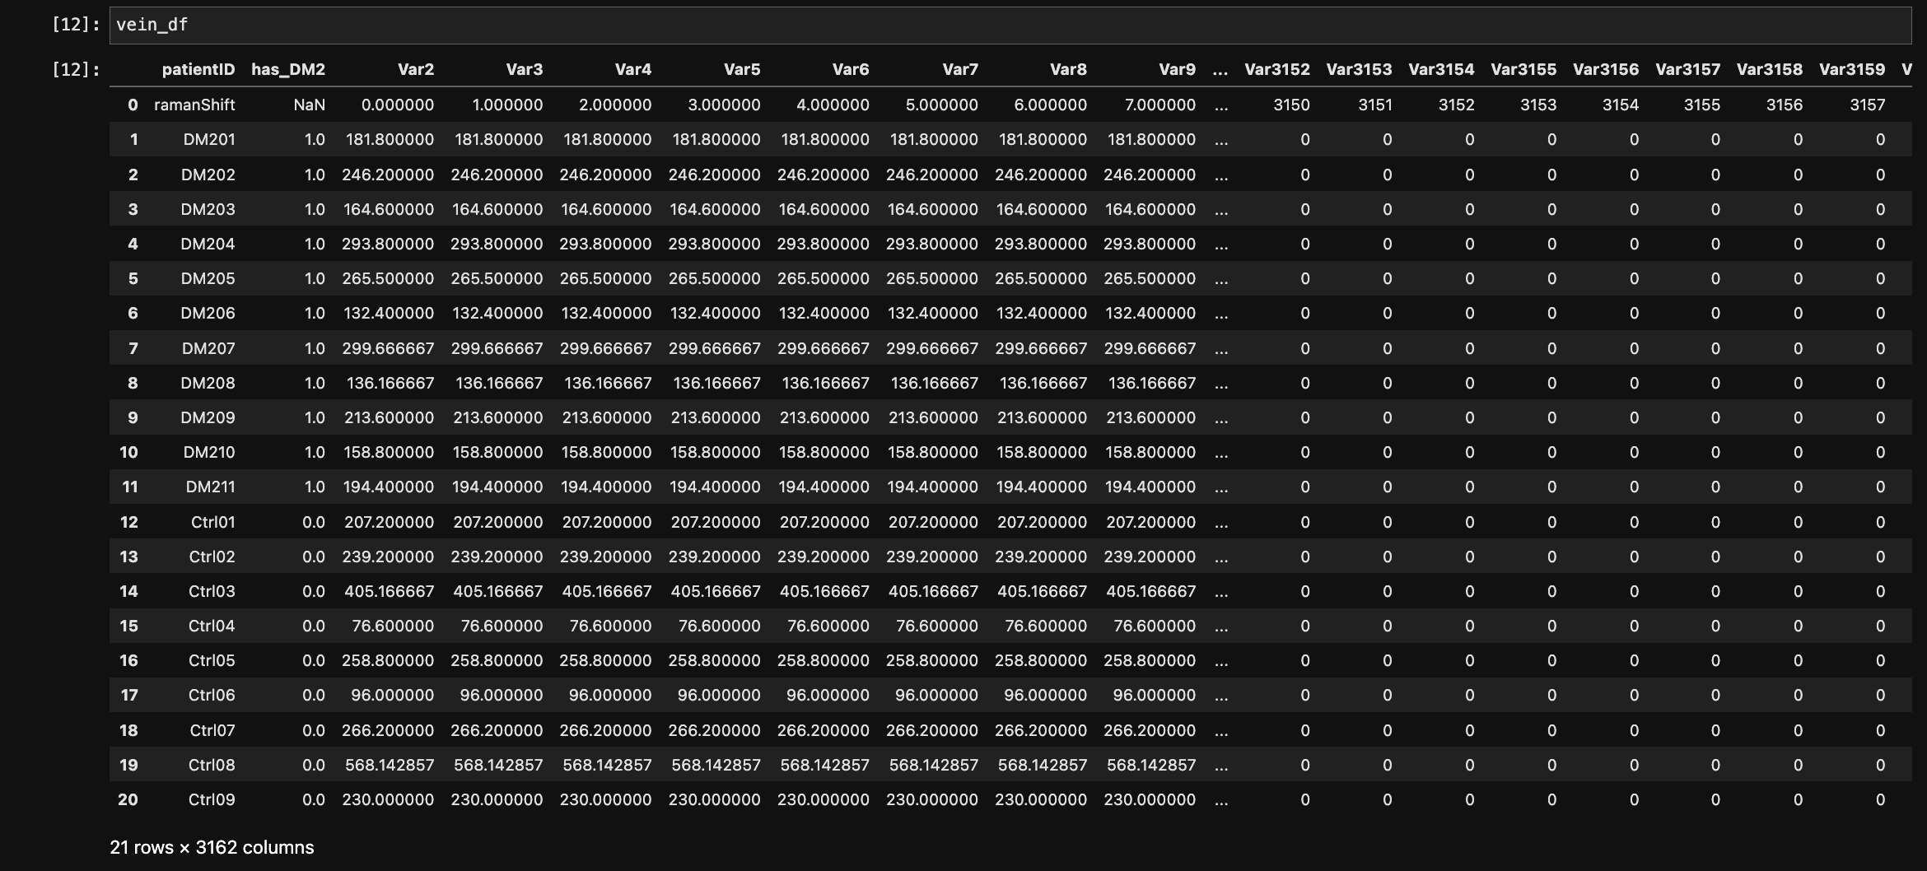

1. AGEs:

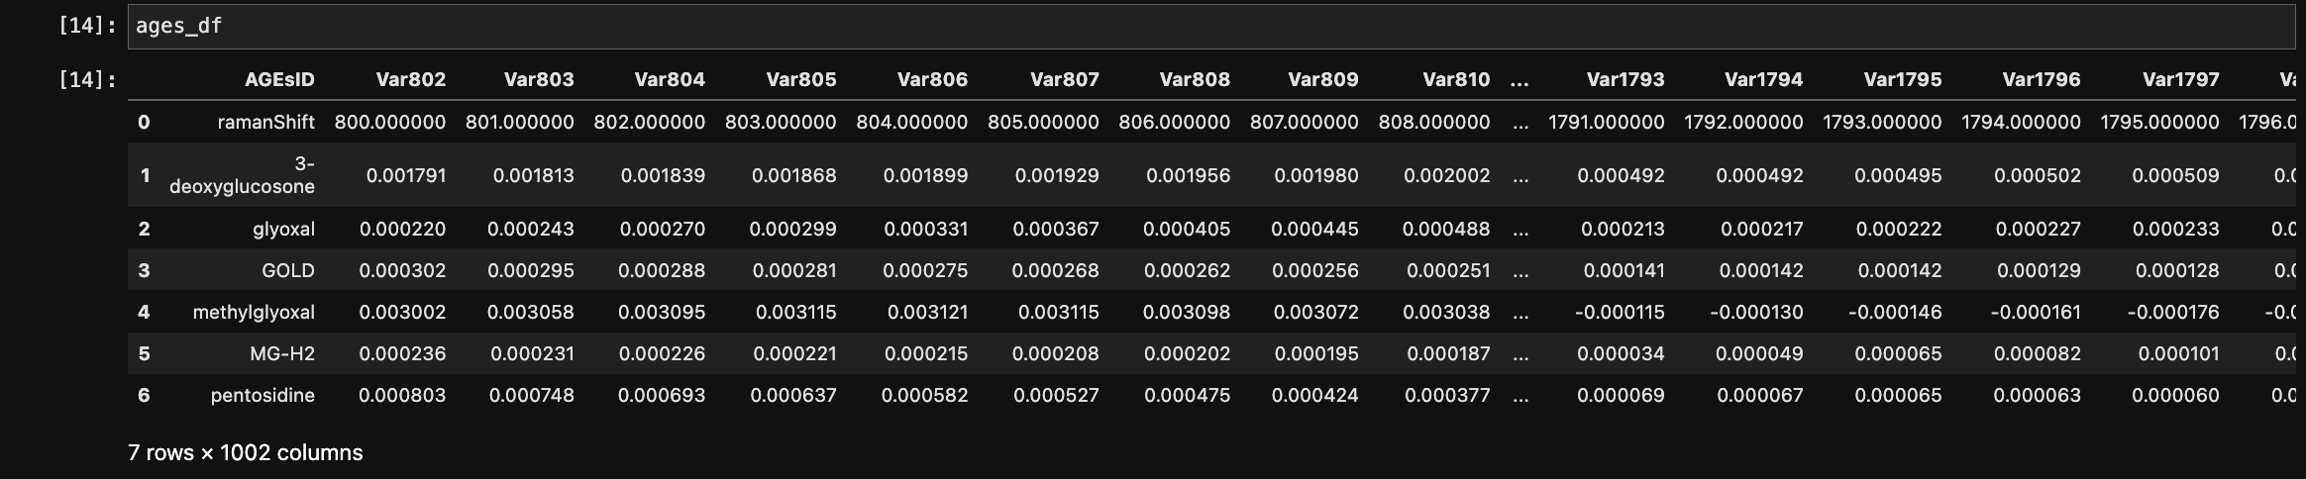

For the dataset from 1 to 4, these are the features:

* patientID
* has_DM2
* raman signal : 3160 columns

The feature patientID is not needed for data processing therefore it will be removed. Has_DM2 is the target column that has value 0 and 1 corresponding to Control and DM2 class. Hence, the method will be used for machine learning task is **Supervised learning**, the problem can be described as **Binary Classification.**

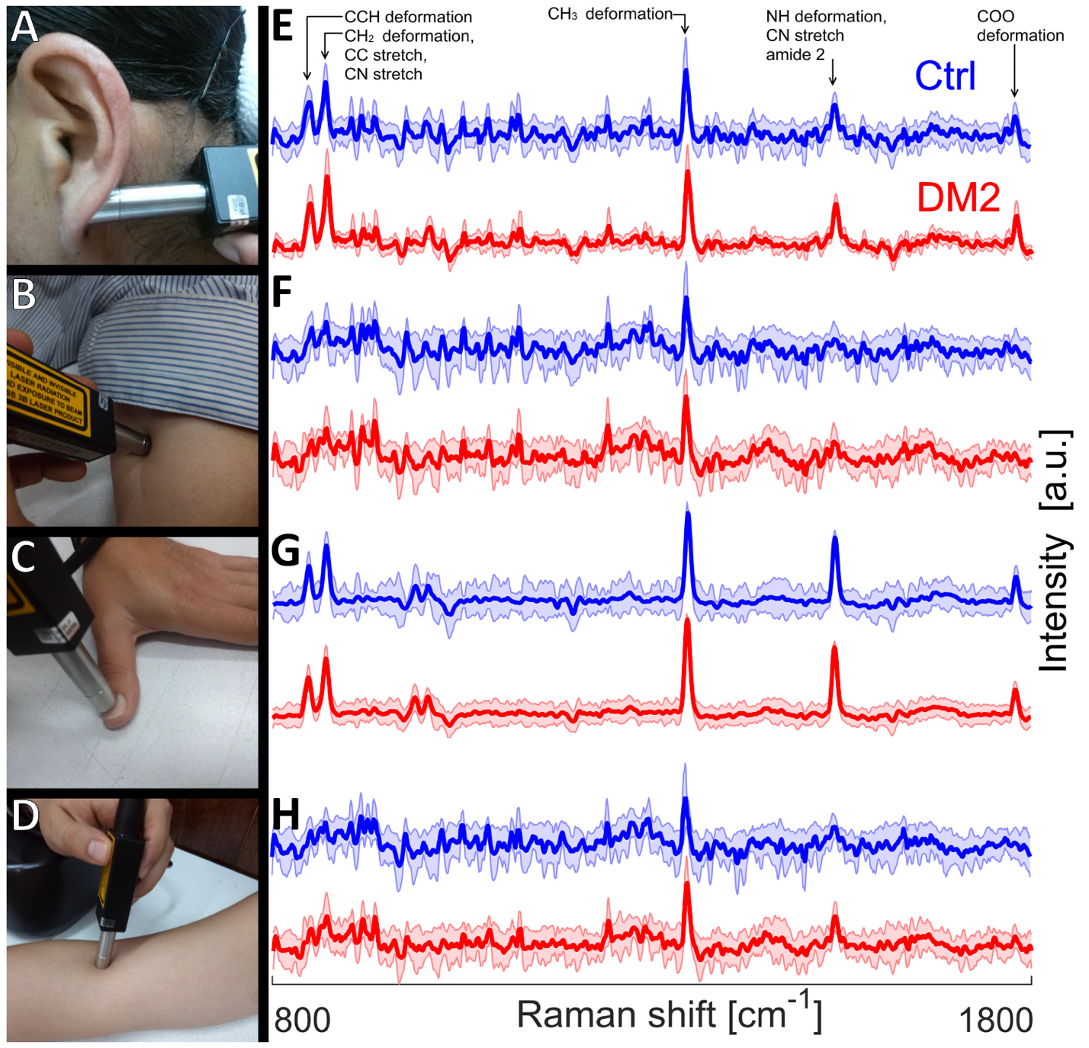

Figure 1. Images of skin sites for in vivo Raman spectra acquisition: (A) ear lobe, (B) inner arm (C) thumb nail (D) median cubital vein. Also shown at the right side are the corresponding Raman measurements (mean ± standard deviation) acquired at an excitation wavelength of 785nm (E-H).

# Data Preprocessing

Several polynomial fitting algorithm were investigated with the purpose of removing background fluorescence in the original signal. However, to preserve the clarity of data, IModPoly method proposed by [] was used for the experiment. The Raman spectrum without fluorescence is computed by subtracting the adjusted polynomial from the original Raman spectrum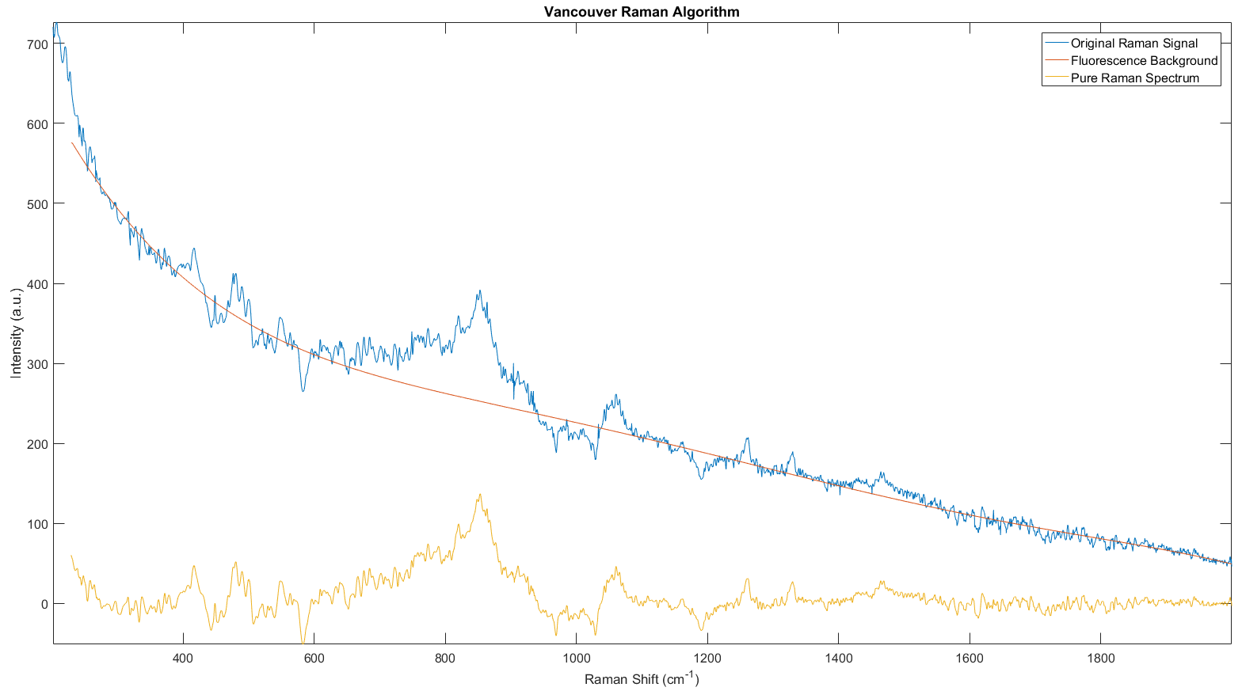



After receiving pure Raman signal, the data is then cropped to range 800-1800 cm-1

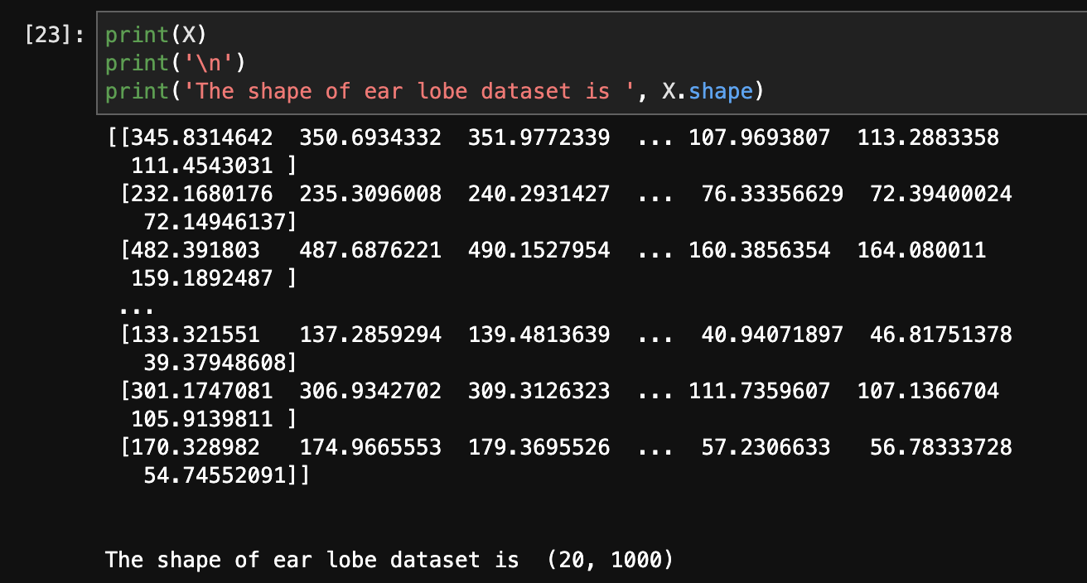

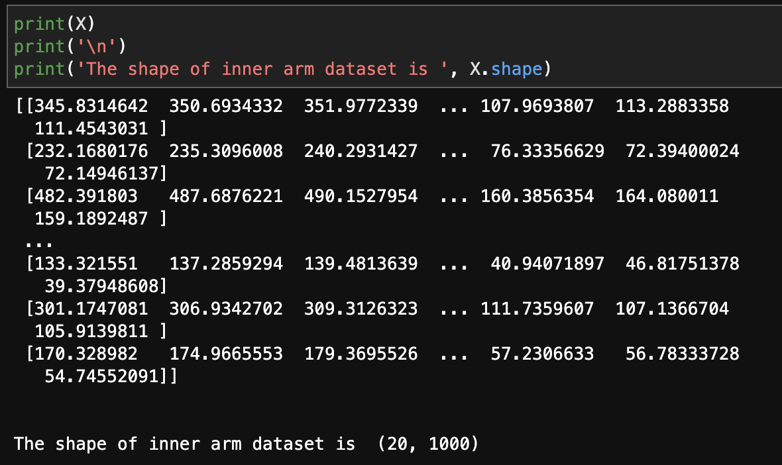

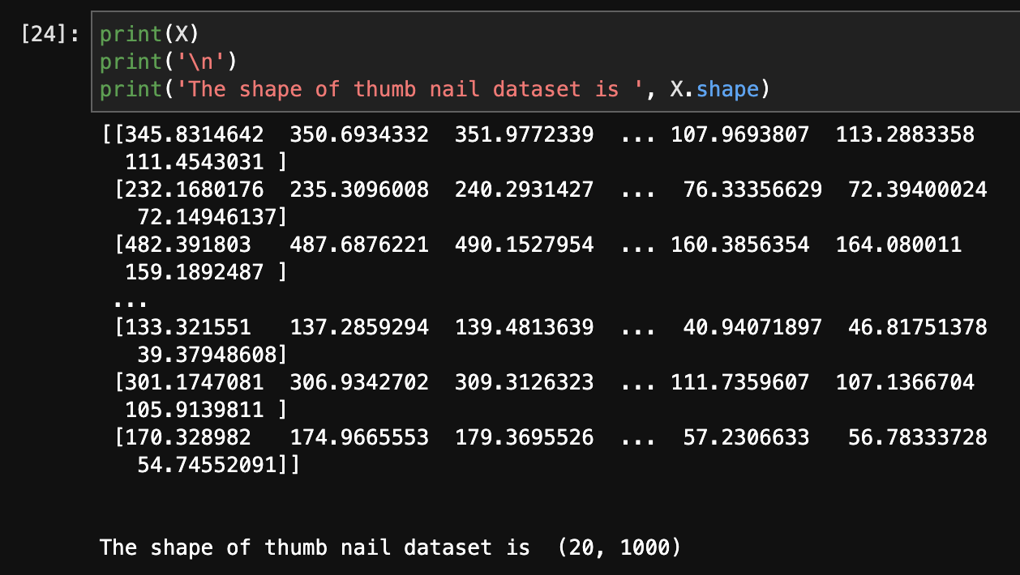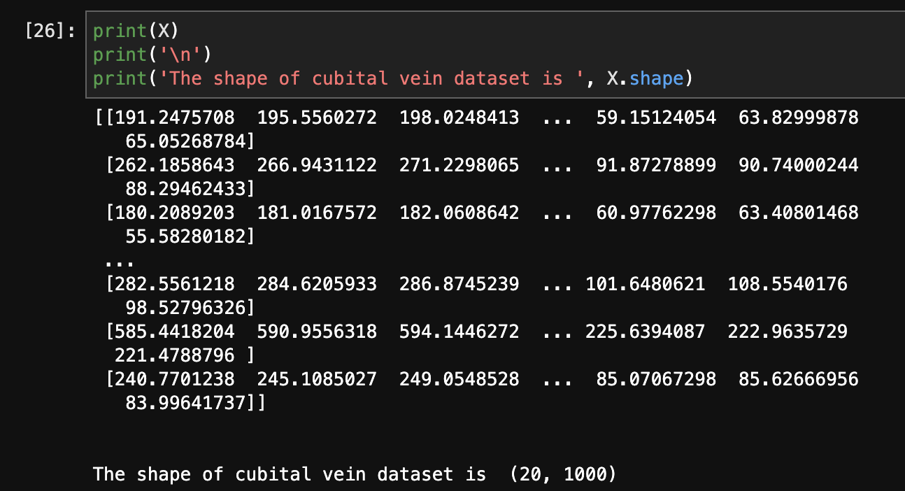

After cropping the signal, the data is then normalized with AUC = 1 in Matlab (this function is defined by Edgar Guevara)

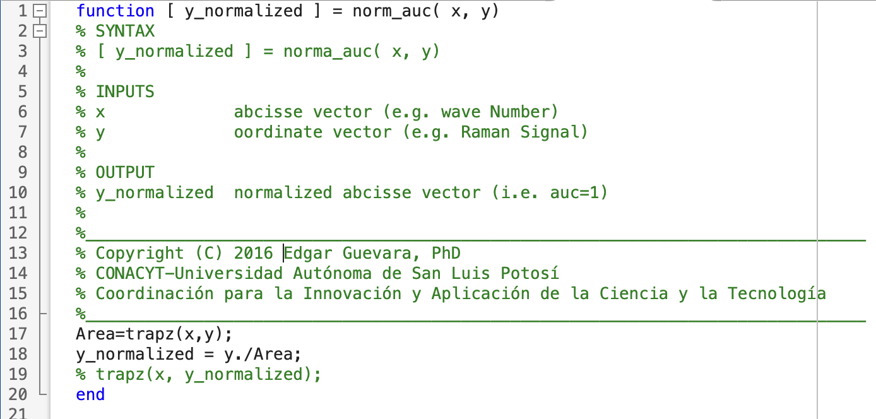

Then after fitting the signal to normalize function, we get normalized data for 4 dataset:

1. Ear Lobe:



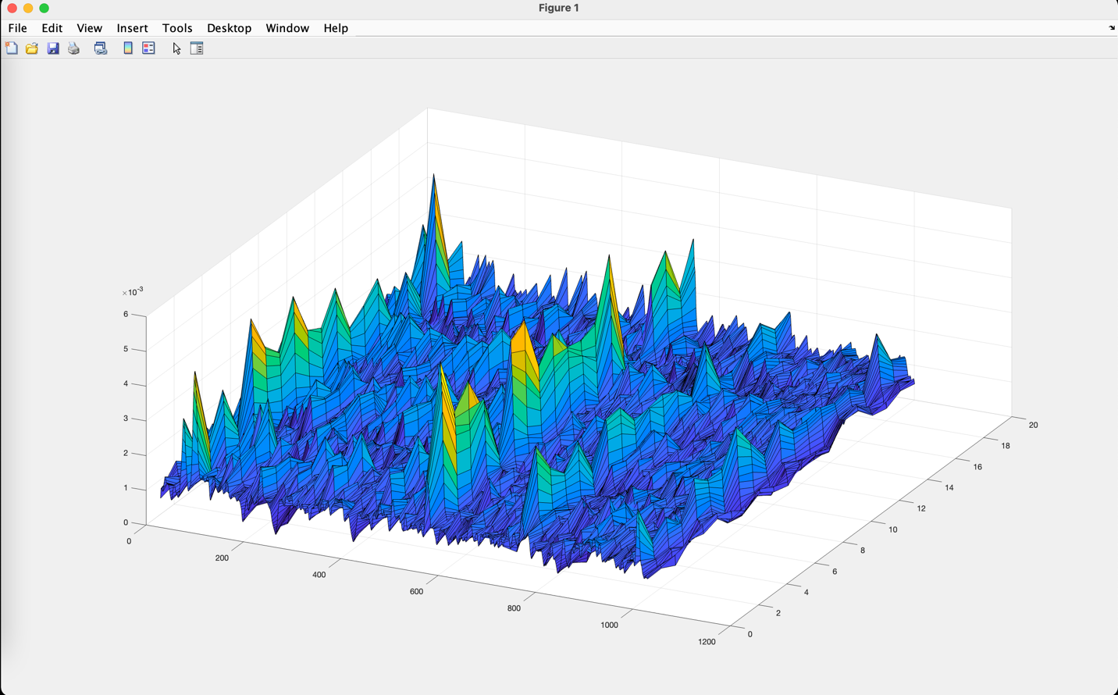

1. Inner Arm



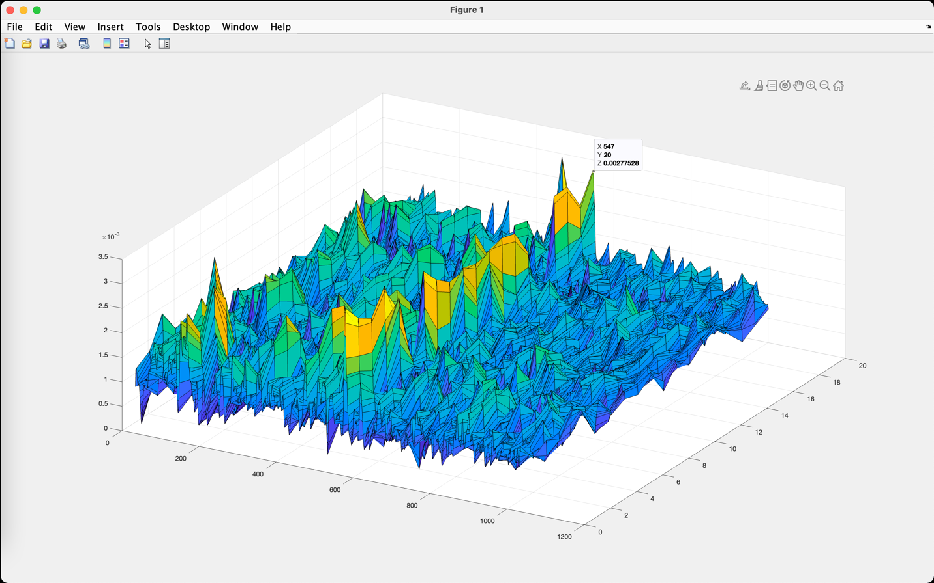

1. Thumb Nail



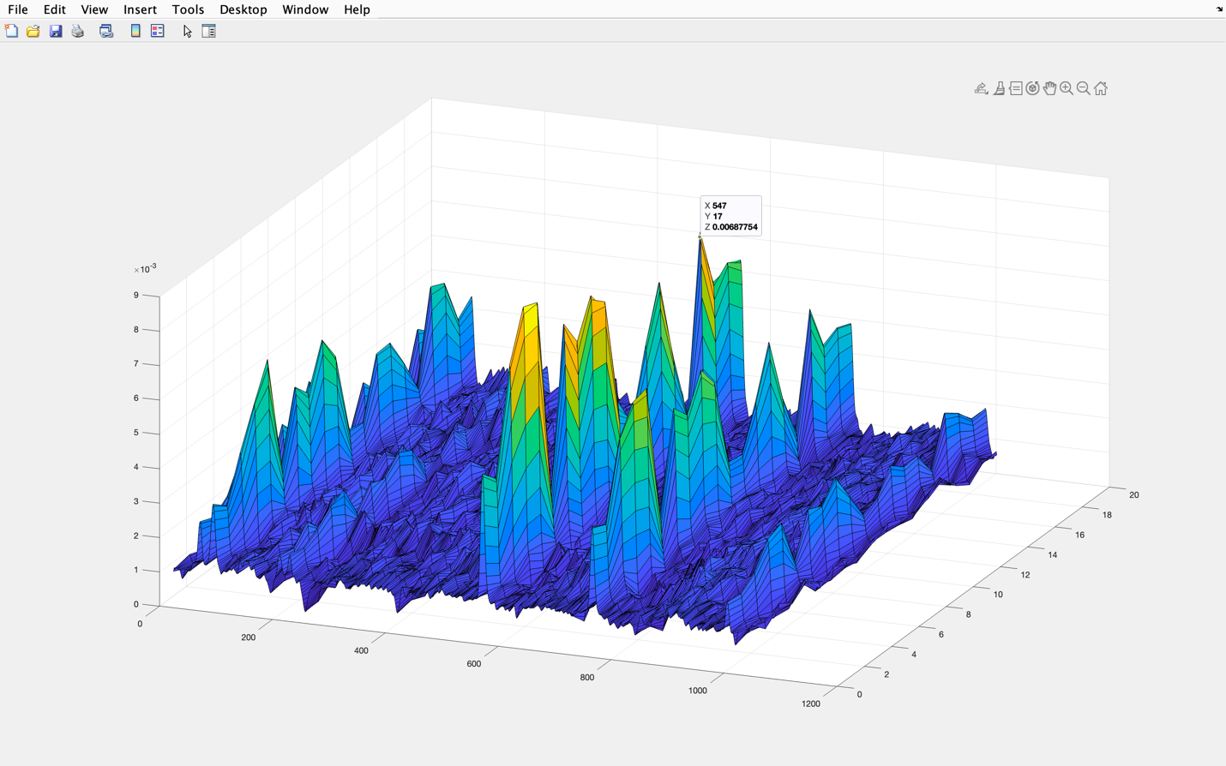

1. Cubital Vein



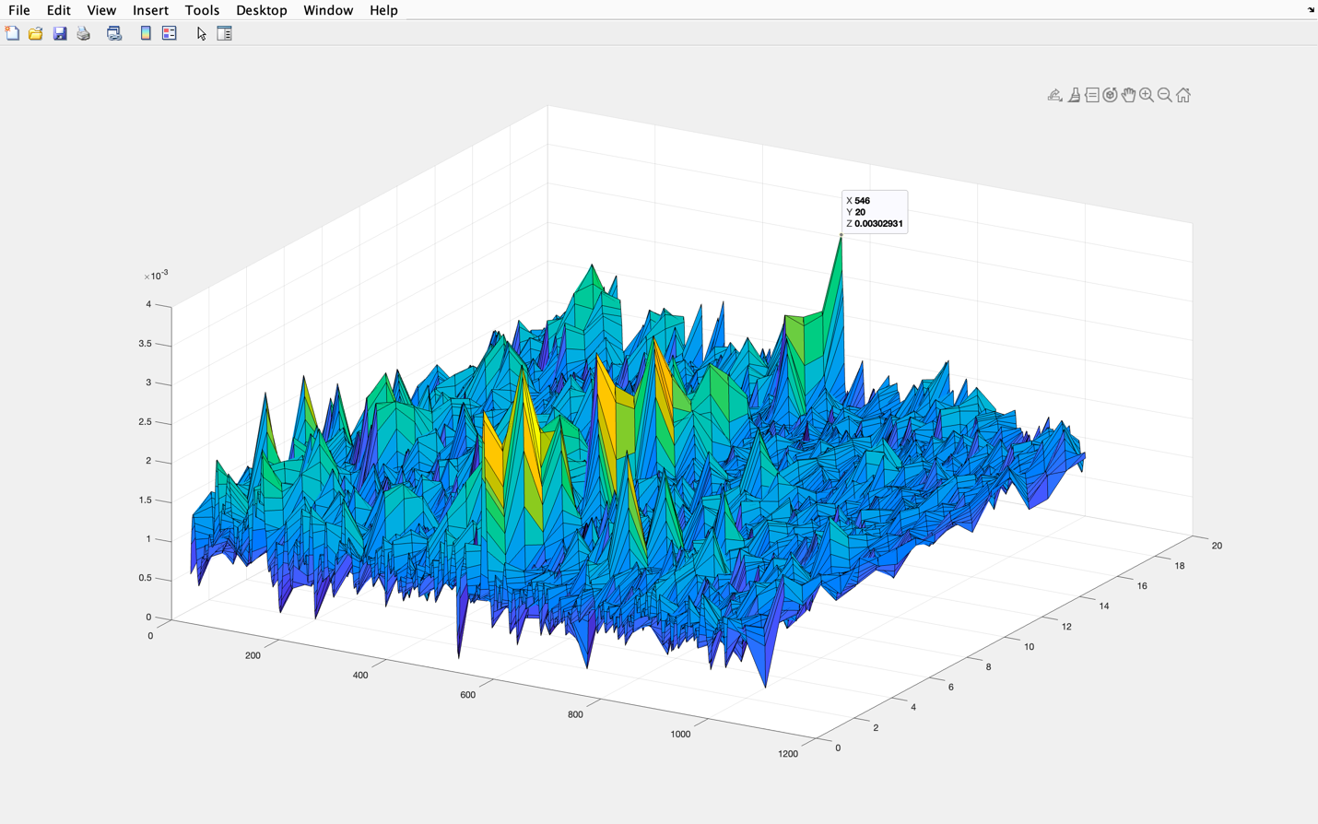

There is no exact seperation between 2 classes.

# Dimensionality Reduction

Given 1000 dimension for each observation, it is hard to fit into an estimator with large number of features. The main idea of principal component analysis (PCA) is to reduce the dimensionality of a data set consisting of many variables correlated with each other, either heavily or lightly, while retaining the variation present in the dataset, up to the maximum extent. The same is done by transforming the variables to a new set of variables, which are known as the principal components (PCs) and are orthogonal, ordered such that the retention of variation present in the original variables decreases as we move down in the order. So, in this way, the 1st principal component retains maximum variation that was present in the original components. The principal components are the eigenvectors of a covariance matrix, and hence they are orthogonal.

As described in [], a PCA step is necessary to solve problems with high dimension data. [] shows that PCA-SVM analysis added to Raman spectroscopy significantly increased the accuracy of this diagnostic tool.





The initial number of components is chosen to match 99% explained variance ratio

# Support Vector Machine

After getting PCA result, Stratified k-fold was applied for cross-validation with k = 10. The following parameter was chosen

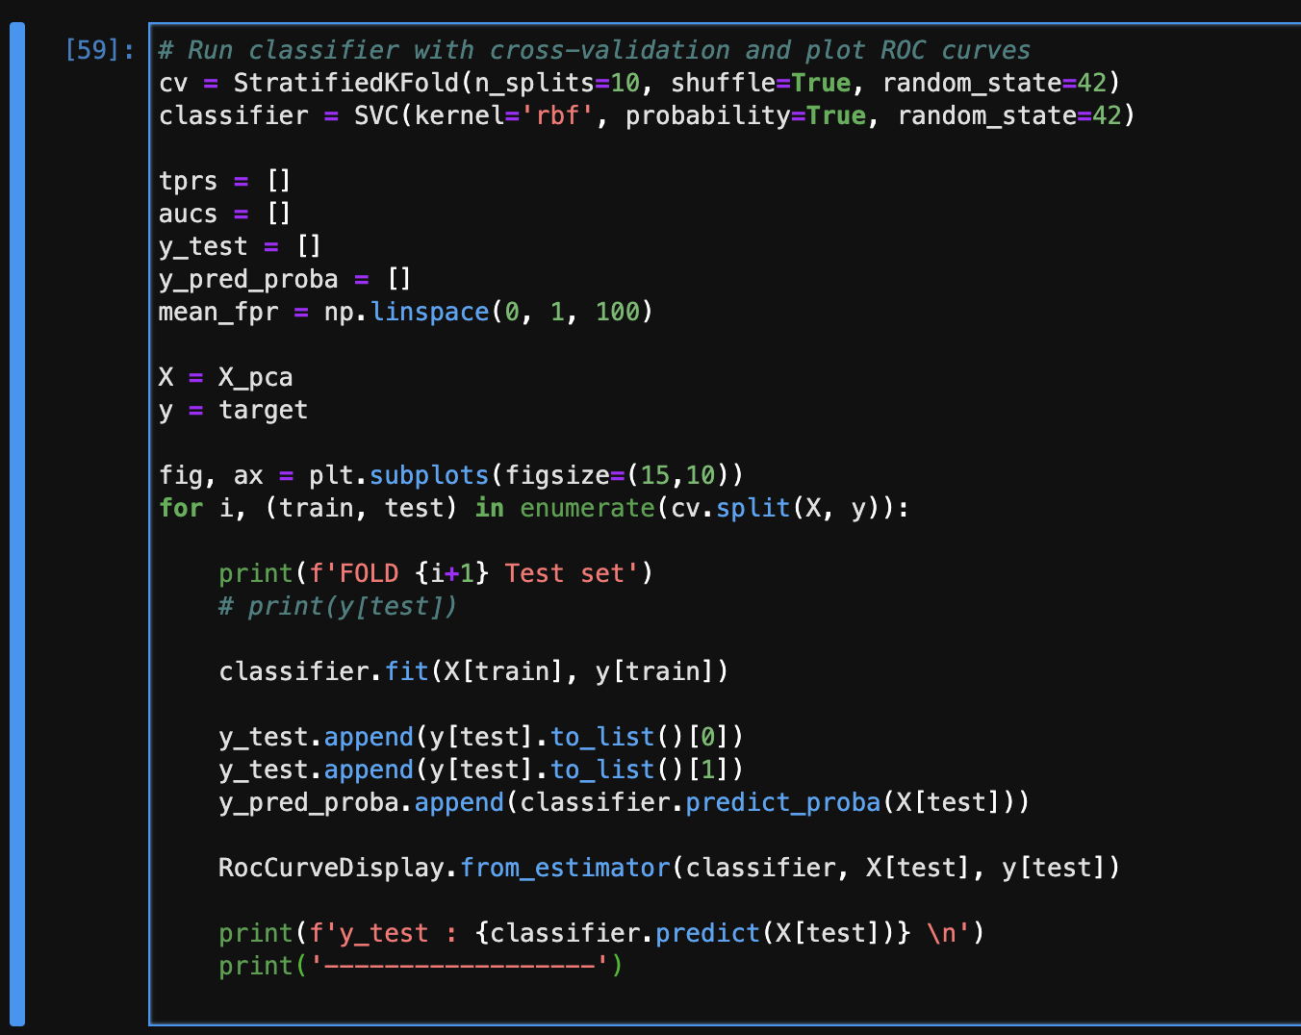





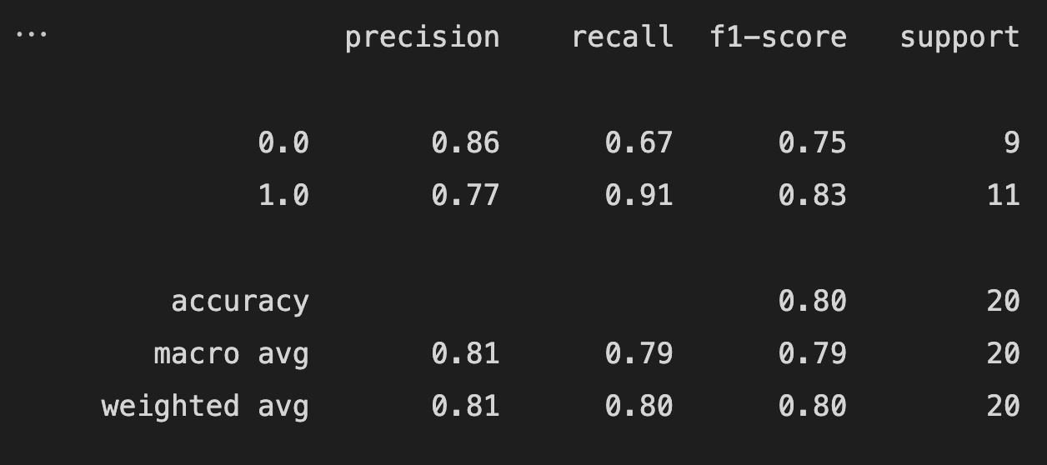

Code Github: <https://github.com/ladcva/raman_spectroscopy>

# Todos

* Run linear kernel SVM with each 2-component in 17 dimension space after PCA
* Run grid search to find best parameter for SVM model
* Investigate in One-shot Learning and Few-shot Learning technique
* Construct LSTM Neural Network for classification task